**Assignment 16.5**

Write a map reduce program to join the below given two datasets using map side join. You can download the datasets from the below link <https://drive.google.com/open?id=0ByJLBTmJojjzSWhfXzI5NGh4RGM>

Dataset description of dataset1.csv is as follows: id,first_name,last_name,email,gender,ip_address

Dataset description of tdataset2.csv is as follows: id,first_name,last_name

Driver class

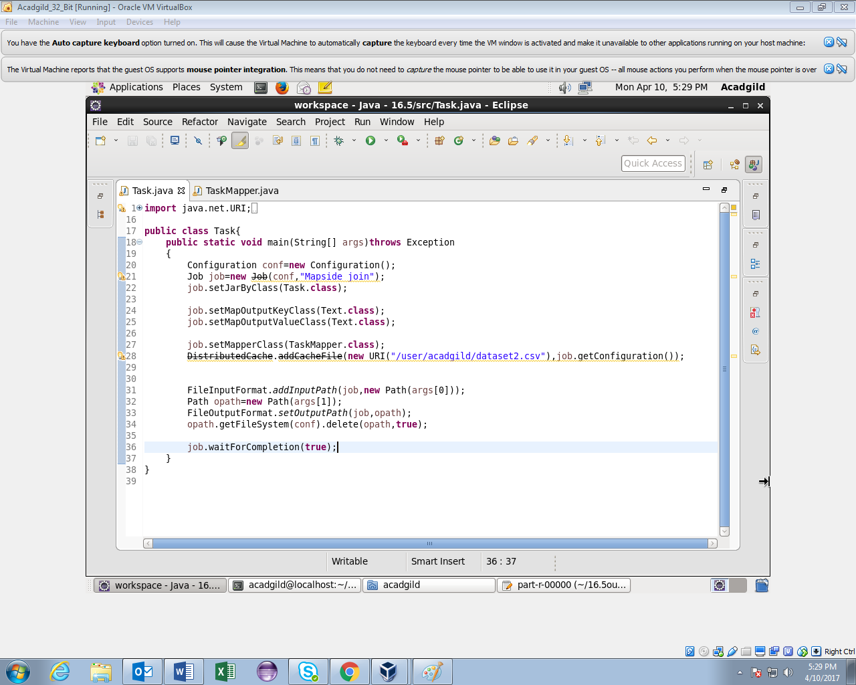

Mapper class

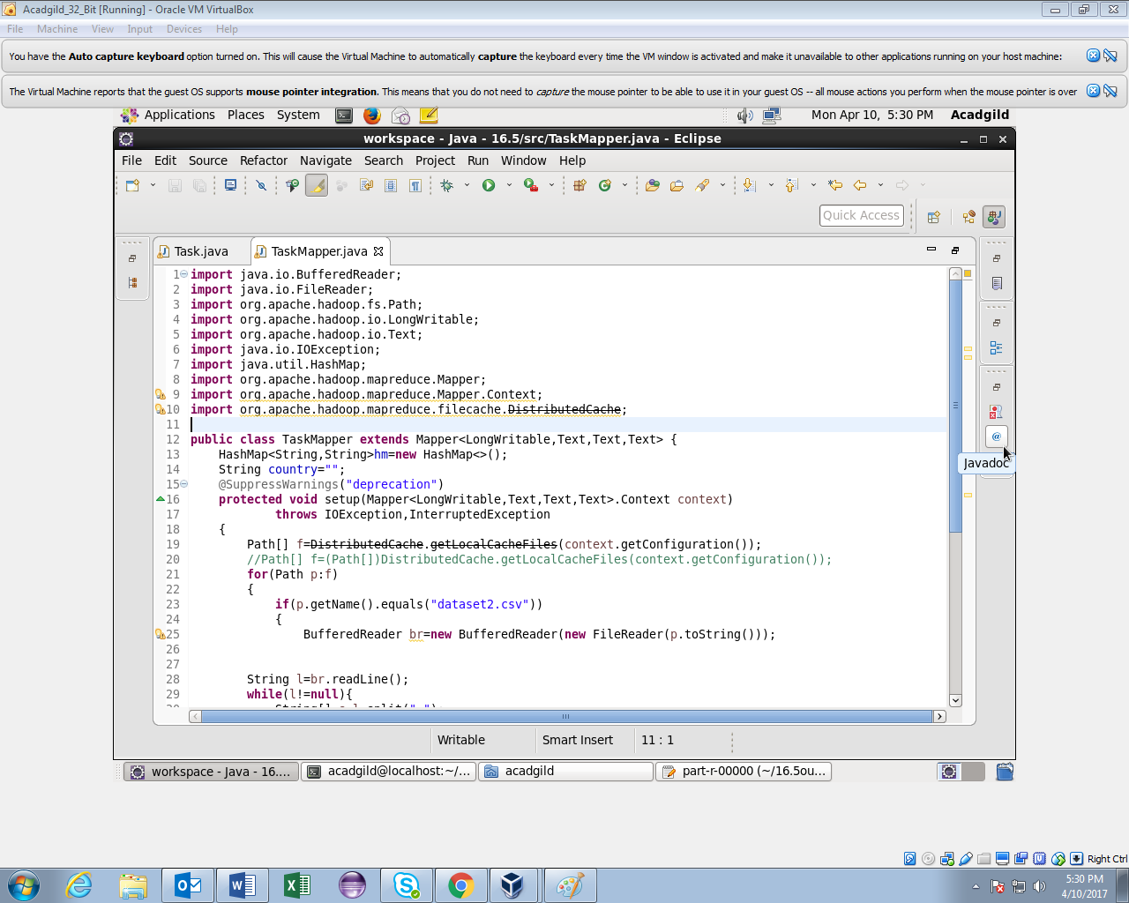

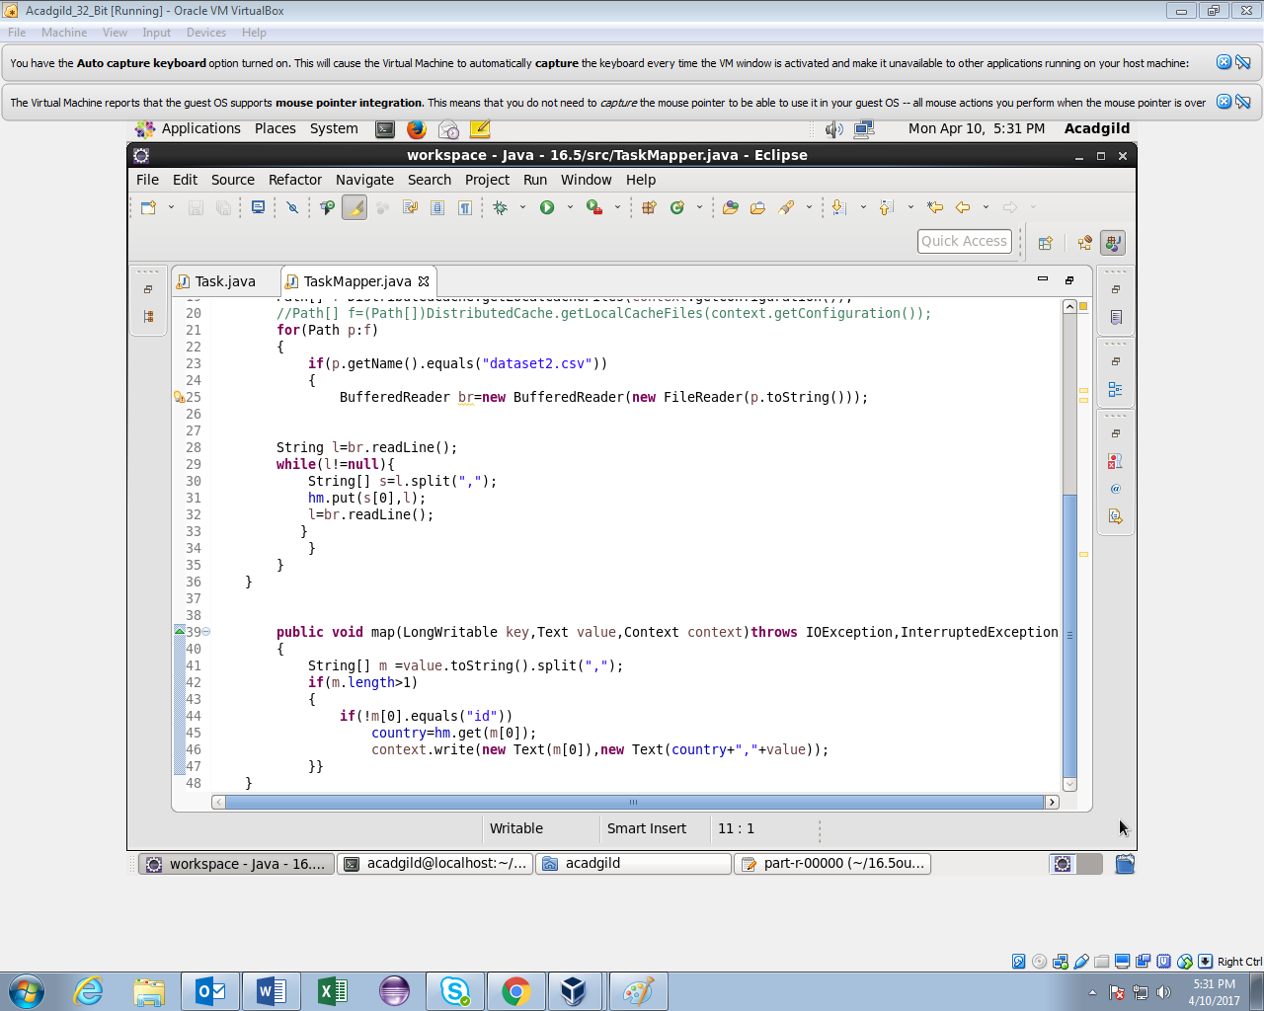

Running jar

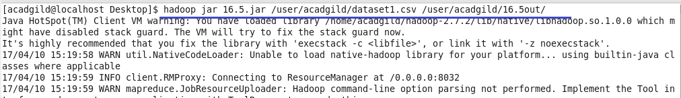

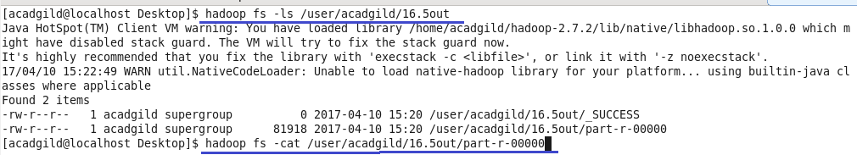

Output

Since the output is very large,I am attaching screenshot of first few records.

